Importing Base Period Data into FRAM

Upon completing a run of the Chinook FRAM Calibration Program, the user can export the resulting base period data as a “base period transfer file” in Microsoft Access database format. The process necessary to import a base period transfer file into FRAM requires several steps and is described below. Be advised that until additional features are implemented, a single database can only successfully be run with one base period. Importing a set of “new” base period data will render the FRAM VS database unable to run with the “old” base period. Accordingly, it is recommended that the user copies the desired database prior to importing new base period data and retains one database version for “old” base period runs and one for “new” base period runs.

To import a new base period dataset into FRAM:

1. Open the FRAM program.
2. Click  and select the desired FRAM VS database.
3. Select a model run (it doesn’t matter which run you select at this point).
4. Click , then .
5. Navigate to and select the desired base period transfer file that was produced by the calibration program.
6. Upon selecting the transfer file, the following window will pop up:

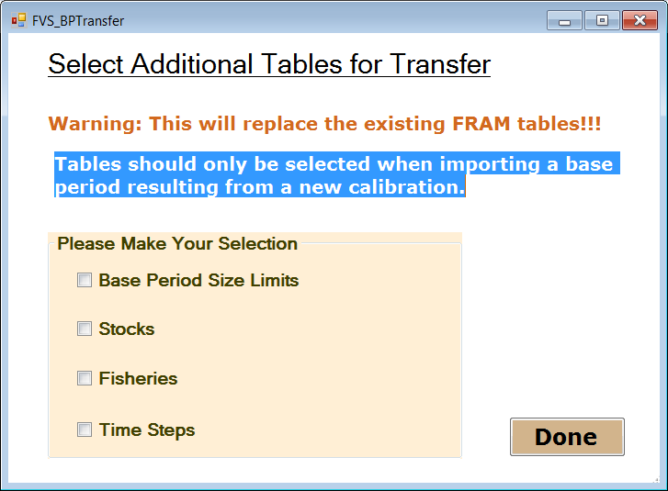

Fisheries and Time Steps are identical between the new and old base periods. However, there are differences in Base Period Size Limits and Stocks. Check the boxes for “Base Period Size Limits” and “Stocks” then select Done.

1. FRAM will import the data from the transfer file and append it to or replace existing data tables in the FRAM VS database. When complete the “FRAM Utilities” page will reappear.
2. Open the FRAM VS access database that the base period data set was just loaded into.
3. Open the “Stock” table and determine the ID that was assigned in the “StockVersion” field (there should only be one unique value here if the “Stock” box was checked in step 6).

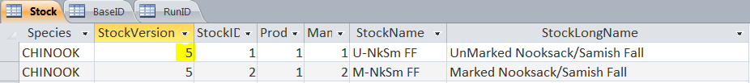

1. Open the “BaseID” table and identify the “BasePeriodID” for the record that was just added (check the “DateCreated” field to make sure the date and time match with when it was imported). **For this record, update the value in the “StockVersion” field to the value that was determined in step 9.**



1. Open the “RunID” table. For any existing model runs stored in the database that you wish to run with the new base period data set, update the value in the “BasePeriodID” field to the value that was identified in step 10.



1. To ensure the import was successful, it is good practice to check and make sure data exist for the new BasePeriodID in the appropriate tables. The following tables include data from the base period dataset:

|  |  |
| --- | --- |
| * “AEQ” | * “BaseCohort” |
| * “BaseExploitationRate” | * “EncounterRateAdjustment” |
| * “FisheryModelStockProportion” | * “Growth” |
| * “IncidentalRate” | * “MaturationRate” |
| * “NaturalMortality” | * “ShakerMortRate” |

*Note that the imported FisheryModelStockProportion actually originates from the “FisheryModelStockProportion_Tot” table in the CalibrationDB.*

1. Return to the FRAM program and exit out of the “FRAM Utilities” page.
2. Reconnect to the FRAM VS database by clicking the  button and reselecting the database.
3. Select the desired model run.
4. You should now be ready to run the model using the new base period dataset.